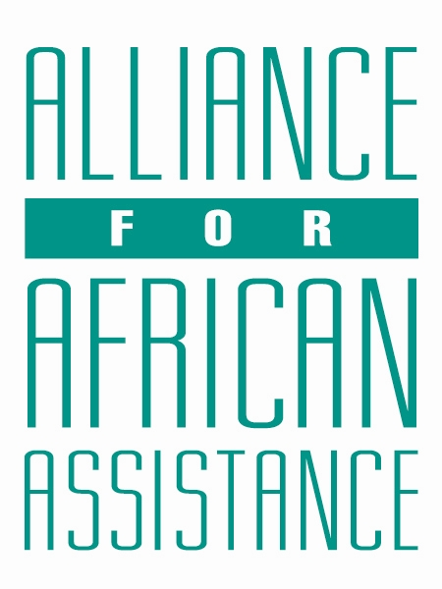
CSP Child Biography Form

PERSONAL INFORMATION
Child’s Village  (Where he/she currently lives) | KANYAGOGA
Child’s District  (Where he/she currently lives) | GULU
Child’s County  (Where he/she currently lives) | LAYIBI-BARDEGE
Child’s Christian Name | LYNETTE EVANS
Child’s Acholi Name | LANYERO
Child’s Date of Birth | 2/6/2006
Child’s Gender | FEMALE
Child’s Favorite Game/Activity | DEBATE

FAMILY INFORMATION
Mother’s Name | ALIMO PASKA
Is mother alive? | DECEASED
Mother’s Profession, if living.
(If farming, which crops are presently being grown?)
Father’s Name
Is father alive? | DECEASED
Father’s Profession, if living.
(If farming, which crops are presently being grown?)
If both parents are living, please give the reason that this child is in need of sponsorship. Based upon the family’s current needs and situation, what kind of activities might enable the parents to become self- sufficient and able to pay the costs of educating their children?
If parents have passed away, please give the reason for their passing (so long as the family is comfortable sharing this information. If the family is not comfortable sharing, please state this) | THE MOTHER PASSED ON WHILE GIVING BIRTH TO EVANS AND THE FATHER DIED IN A ROAD ACCIDENT
Guardian’s Name (If not parent(s) | ALUM SUNDAY ODYE
Guardian’s relationship to the child (aunt, neighbor, grandfather, etc.) | AUNT-SISTER TO THE LATE MOTHER
Guardian’s Profession (If farming, which crops are presently being grown?) | SMALL BUSINESS
Number of sisters with whom the child lives | NIL
Number of brothers with whom the child lives | NIL
Others with whom child lives | 01
Description of what the child helps with at home | WASHING UTENSILS
Additional Information

ACADEMIC INFORMATION
Is child currently attending school? | YES
Name of School | SACRED HEART SECONDARY SCHOOL
Class Level | S.1
Favorite Subject | BIOLOGY
Future Dreams (Profession) | DOCTOR

