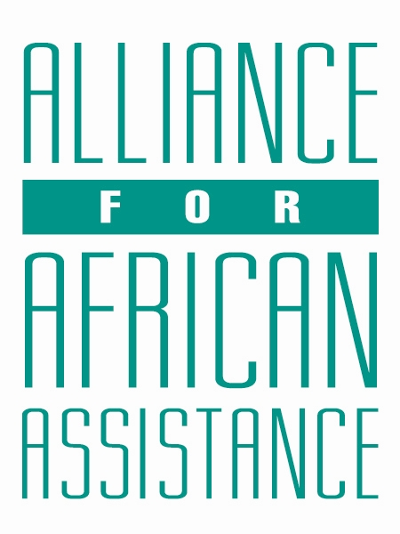
CSP Child Biography Form

PERSONAL INFORMATION
Child’s Village  (Where he/she currently lives) | JIMO
Child’s District  (Where he/she currently lives) | AMURU
Child’s County  (Where he/she currently lives) | KILAK NORTH
Child’s Christian Name | VANESSA
Child’s Acholi Name | AGENORWOT
Child’s Date of Birth | 16/08/2008
Child’s Gender | FEMALE
Child’s Favorite Game/Activity | BATANINTON

FAMILY INFORMATION
Mother’s Name | LAMUNU AGNES
Is mother alive? | YES
Mother’s Profession, if living.  (If farming, which crops are presently being grown?) | PEASANT FARMER-BEANS
Father’s Name | OTIM RICHARD
Is father alive? | DECEASED
Father’s Profession, if living.
(If farming, which crops are presently being grown?)
If both parents are living, please give the reason that this child is in need of sponsorship. Based upon the family’s current needs and situation, what kind of activities might enable the parents to become self- sufficient and able to pay the costs of educating their children?
If parents have passed away, please give the reason for their passing (so long as the family is comfortable sharing this information. If the family is not comfortable sharing, please state this)
Guardian’s Name (If not parent(s)
Guardian’s relationship to the child (aunt, neighbor, grandfather, etc.)
Guardian’s Profession (If farming, which crops are presently being grown?)
Number of sisters with whom the child lives | 02
Number of brothers with whom the child lives
Others with whom child lives | 3 COUSINS
Description of what the child helps with at home | COOKING, WASHING UTENSILS AND MAKING PAPER BAGS
Additional Information

ACADEMIC INFORMATION
Is child currently attending school? | YES
Name of School | OUR LADY OF AFRICA
Class Level | S.4
Favorite Subject | PHYSICS
Future Dreams (Profession) | ACCOUNTANT

