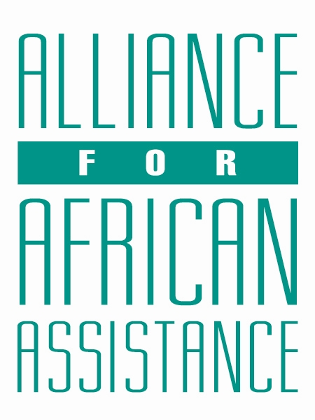
CSP Child Biography Form

PERSONAL INFORMATION
Child’s Village  (Where he/she currently lives) | KABEDOPONG
Child’s District  (Where he/she currently lives) | GULU
Child’s County  (Where he/she currently lives) | PECE-LAROO
Child’s Christian Name | CYNTHIA
Child’s Acholi Name | AMONO
Child’s Date of Birth | 22/2/2007
Child’s Gender | FEMALE
Child’s Favorite Game/Activity | MUSIC & DRAMA

FAMILY INFORMATION
Mother’s Name | ADONG SUSAN IRENE
Is mother alive? | DECEASED
Mother’s Profession, if living.
(If farming, which crops are presently being grown?)
Father’s Name | OKEMA SAMUEL
Is father alive? | YES
Father’s Profession, if living.  (If farming, which crops are presently being grown?) | NONE (DISABLED)
If both parents are living, please give the reason that this child is in need of sponsorship. Based upon the family’s current needs and situation, what kind of activities might enable the parents to become self- sufficient and able to pay the costs of educating their children?
If parents have passed away, please give the reason for their passing (so long as the family is comfortable sharing this information. If the family is not comfortable sharing, please state this) | SHE PASSED ON DUE TO HIV/AIDS
Guardian’s Name (If not parent(s) | ADONG MARY
Guardian’s relationship to the child (aunt, neighbor, grandfather, etc.) | GRAND CHILD
Guardian’s Profession (If farming, which crops are presently being grown?) | PEASANT FARMER
Number of sisters with whom the child lives | 01
Number of brothers with whom the child lives | 01
Others with whom child lives | 03
Description of what the child helps with at home | FARMING AND COOKING
Additional Information

ACADEMIC INFORMATION
Is child currently attending school? | YES
Name of School | KING JAMES
Class Level | S.1
Favorite Subject | ENGLISH
Future Dreams (Profession) | ACCOUNTANT

