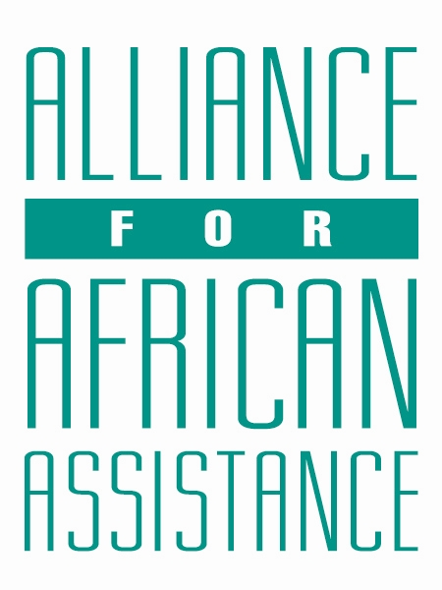
CSP Child Biography Form

PERSONAL INFORMATION
Child’s Village  (Where he/she currently lives) | KASUBI GOWAN QUARTERS
Child’s District  (Where he/she currently lives) | GULU CITY
Child’s County  (Where he/she currently lives) | BARDEGE-LAYIBI
Child’s Christian Name | BENNY BRIGHT
Child’s Acholi Name | RWOTOMIYA
Child’s Date of Birth | 3/04/2011
Child’s Gender | MALE
Child’s Favorite Game/Activity | BASKET BALL

FAMILY INFORMATION
Mother’s Name | AJOK EVELYN LIZS
Is mother alive? | DECEASED
Mother’s Profession, if living.
(If farming, which crops are presently being grown?)
Father’s Name | OPIRA CHARLES CHRISTOPHER
Is father alive? | YES
Father’s Profession, if living.  (If farming, which crops are presently being grown?) | TEACHING
If both parents are living, please give the reason that this child is in need of sponsorship. Based upon the family’s current needs and situation, what kind of activities might enable the parents to become self- sufficient and able to pay the costs of educating their children?
If parents have passed away, please give the reason for their passing (so long as the family is comfortable sharing this information. If the family is not comfortable sharing, please state this)
Guardian’s Name (If not parent(s)
Guardian’s relationship to the child (aunt, neighbor, grandfather, etc.)
Guardian’s Profession (If farming, which crops are presently being grown?)
Number of sisters with whom the child lives | O4
Number of brothers with whom the child lives | 06
Others with whom child lives
Description of what the child helps with at home | DOMESTIC CHORES AND DIGGING
Additional Information | HE IS A BRIGHT CHILD AND TALENTED IN GAMES

ACADEMIC INFORMATION
Is child currently attending school? | YES
Name of School | CHRIST CHURCH PRIMARY SCHOOL
Class Level | SAT PLE IN 2024(JOINING S.1 IN 2025)
Favorite Subject | SCIENCE
Future Dreams (Profession) | DOCTOR

